
736 F Street
Arcata, CA 95521
(707) 822-8184
eservices@cityofarcata.org • www.cityofarcata.org

Approved by: Date:___________

Project Erosion and Sedimentation Control Plan Template
(Projects Less Than One Acre)

State regulations and City Building and Grading Permits require anyone doing land disturbing activities to include an Erosion and Sediment Control Plan which identifies methods that will be used to protect area creeks, rivers, wetlands, Humboldt Bay and other surface waters from sediment or other pollutants that are typically present at construction sites. This template can be used to develop the Sediment and Erosion Control Plan for your project if your project disturbs less than one acre.

Contact Person:______________________________________
Phone: Cell Phone: Email:________________________
Construction Site Project Name: ________________________________________
Physical Site Address: ________________________________________________
Grading Project Size –(Sq. ft. and acres - include all areas to be graded i.e. foundation, driveways landscaping drainage etc.):___________________________________________
Area of disturbance (Sq. ft. and acres):_____________________________________
Grading Start Date:_________________ Date when site work will be completed: _____________________
A. Nature of the Construction Activity
Provide a general description of the construction activities at your site include information on all areas to be graded for foundations, drainage improvements, driveways, roads, utilities, landscaping etc.

- General Description of Project:

- Applicable state and federal permits (check all that apply) and attach to this document:
___California Dept. Fish and Wildlife 600 ___Army Corps of Engineers Permit
___Coastal Development Permit ___U. S. Fish and Wildlife Service Consultation
___Water Board 401 Certification ___National Marine Fisheries Service Consultation

Is the total area of grading less than ¼ acre (10,899.9 ft²)? Yes ____ No____
Will the grading occur on slopes less than 15%? Yes ____ No____
Is the proposed grading located more than 100 ft. from a creek/wetland? Yes ____ No____

If you answered YES to all three questions complete Section B and provide a site plan. Show the location of all erosion and sediment control techniques that you check yes to in Section B. Erosion and sediment control techniques are also called Best Management Practices (BMPs). More detailed information on BMPs can be found at http://www.dot.ca.gov/hq/construc/stormwater/CSBMPM_303_Final.pdf

If you answered NO to at least one of the questions complete Sections B and C and provide a site plan showing all erosion and sediment control BMPs that you checked.

All applicants must insure that selected BMPs are installed two days in advance of a weather forecast of ½ inch or more of rain at any time during of the year. BMPs must also be installed prior to the onset of the rainy season which begins on October 15 and be maintained until the end of the rainy season which usually ends April 15. If rainy weather continues beyond that date BMPs must continue to be in place and maintained so they work properly

Section B. Primary Construction Site Erosion and Sediment Control Best Management Practices to be used for small projects where slopes are less than 15%, the graded area is less than ¼ acre, and the proposed grading is not within 100 feet of a creek or wetland.

The following 8 measures should be used unless the listed BMP does not apply to your project. For example if the entire site is a paved site and there is no existing vegetation BMPs 1 and 2 are not applicable.

- Preservation of natural features, vegetation and soil Yes____ Not Applicable _____
Preserve/protect existing vegetation outside the construction area. Avoid activity under the drip line of remaining trees. Protect vegetation to be preserved within the construction area with temporary fencing. Retain protective measures until all construction and site cleanup activity is complete.
- Disturbed vegetated areas will be re-vegetated. Yes____ Not Applicable _____

Seeding will be used with mulch (ex: weed free straw) as soon as practical to protect exposed soil from raindrop impact or wind erosion.

- Protection of storm drain inlets Yes____ Not Applicable _____

Every storm drain inlet located on, adjacent to or downhill from the project site will be protected with at least one type of inlet protection, i.e. gravel bag barrier, block & gravel filter, excavated drop inlet sediment trap, or filter fabric fence (BMP SE-10).
- Silt fencing and/or wattles will be installed. Yes____ Not Applicable _____

Silt fencing or wattles will be installed at downhill locations, five feet from the toe of stockpiles, and as necessary to retain all sediment on site.

- Protect exposed soil and building materials stock piles Yes____ Not Applicable _____
Soil and building materials stock piles (sand, compost, cement, etc) will be covered with mulch, plastic sheeting or tarps to protect them from rain or wind.
- Install Drainage courses Yes____ Not Applicable _____

Drainage courses will be installed (construct earthen dike(s) or drainage swale(s) (BMP EC-9) to control surface water flow over cut and fill slopes and direct surface water away from stockpiles.

- All construction site entrance/exits will be stabilized Yes____ Not Applicable _____

Aggregate (e.g. gravel) underlain with filter cloth, will be located where traffic enters or leaves the construction site (TC-1).

- Material handling and waste management Yes____ Not Applicable _____

If your project uses hazardous materials, pesticides, herbicides, and fertilizers. comply with all federal and state regulations. Use a designated waste collection area with covered containers for solid waste. Pesticides, herbicides, and fertilizers must be stored in a dry covered area and applied correctly.

Section C. Additional Construction Site Erosion and Sediment Control Best Management Practices to be used for projects disturbing between ¼ to one acre, contain slopes greater than 15%, or located within 100 feet of a creek or wetland or where springs are present.
Select all that apply from the following list of Best Management Practices (BMPs) to be implemented in addition to the practices selected in Section B. More information about the BMPs can be found on the BMP Fact Sheets located at the end of this document in Exhibit A.
- Scheduling Construction Activity
- Avoid construction during the rainy season from October 15 through April 15. Provide enough time before rainfall begins to stabilize the soil with vegetation or mulch or install sediment trapping devices.
- Slow storm water flow
- Velocity Dissipation Devices will be installed at the outlets of culverts, conduits or channels to prevent erosion (BMP EC-10).

A temporary check dam of rock, gravel bags, sandbags, fiber rolls, will be placed across a swale or drainage ditch to reduce water velocity, promote sedimentation and reduce erosion (see SE-4).

- Erosion control matting to protect soils
Mattings of natural materials or geotextiles will be used to cover the soil surface to reduce erosion from rainfall impact or wind erosion (BMP EC-7).
- Perimeter sediment control
Silt fence will be installed on a level contour to trap sediment-laden runoff from disturbed areas to promote sedimentation behind the fence (BMP SE-1).

Fiber roles will be placed along the perimeter of the project to remove sediment from runoff (see BMP SE-5).

A sandbag barrier will be placed on a level contour to intercept sheet flow and pond runoff to allow sediment to settle out (BMP SE-8).

Straw bales will be placed end-to-end on a level contour to intercept sheet flow to pond runoff to allow sediment to settle out (BMP SE-9).

- Wind erosion control
Apply water, dust palliatives, gravel, temporary vegetation, or mulching to prevent or alleviate dust.
- Management of washout areas (concrete, paints, stucco, etc.)
Designate concrete, paint and stucco washout areas. Collect and retain concrete, paints and stucco washout water or chemicals and solids in leak proof containers and dispose of in a permitted sewer line so it does not reach soil surface and migrate to surface or ground water.
- Control of vehicle/equipment fueling to contractor's staging area
Store and use petroleum products in dry covered areas and perform vehicle fueling in designated areas with materials and equipment available to contain and clean up any spills that may occur.
- Vehicle and equipment cleaning performed off-site
Wash vehicles and equipment at an appropriate site where wash water will be directed to the sewer so it is treated at the wastewater treatment plant. Show location on construction site plan.
- Spill prevention and control
Check equipment, hydraulic lines, and containers for leaks and corrosion regularly.

Maintain a spill-kit with absorbent materials on site at all times. Clean up spills immediately. For hazardous materials, follow cleanup instructions on the package.

Attach construction site plan identifying location of ALL BMPs and include information on proximity to water bodies and other sensitive areas (streams, wetlands sloughs, Humboldt Bay etc.) See attached example site plan on the next page.
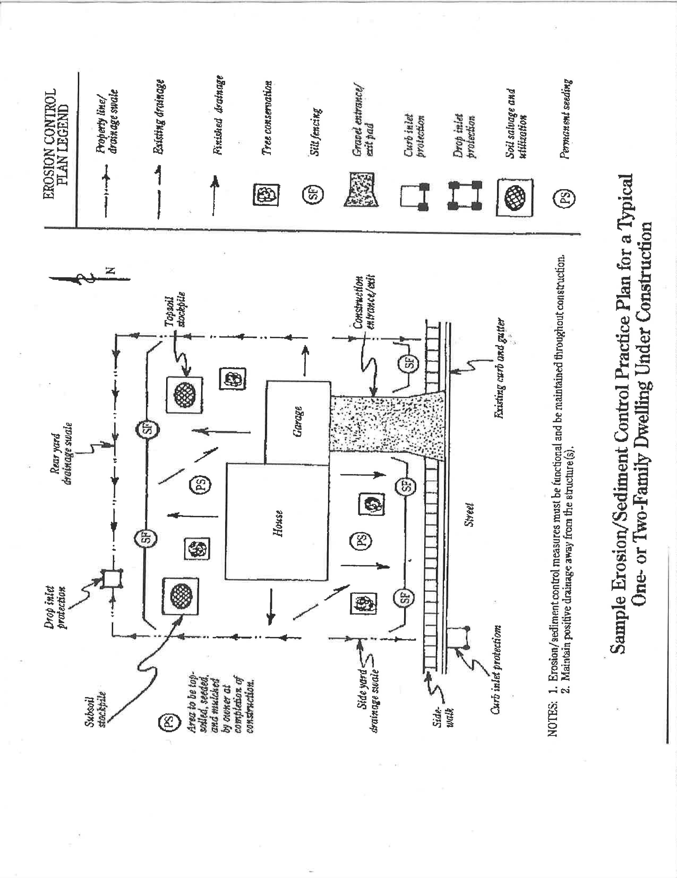

Exhibit A

Best Management Practices
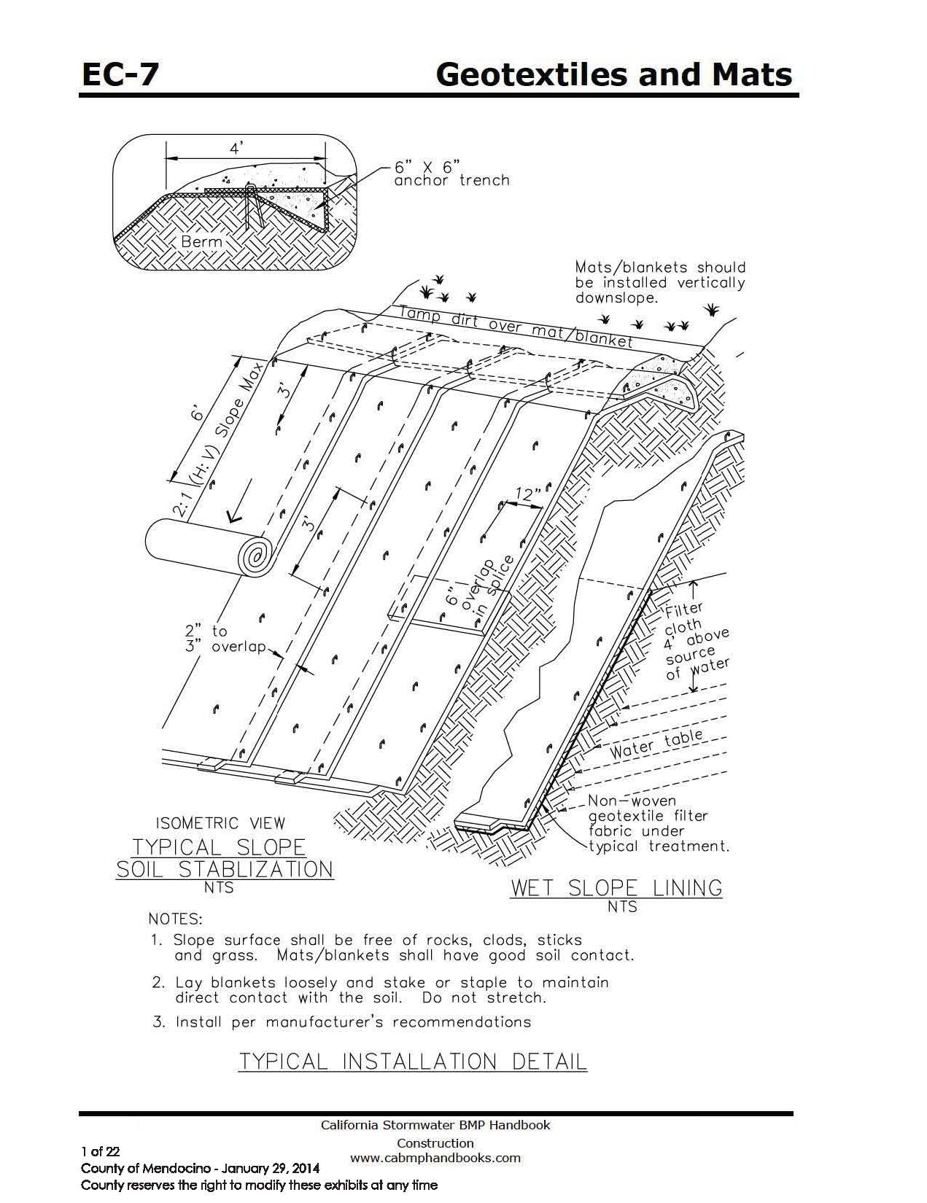

City reserves the right to modify these exhibits at any time

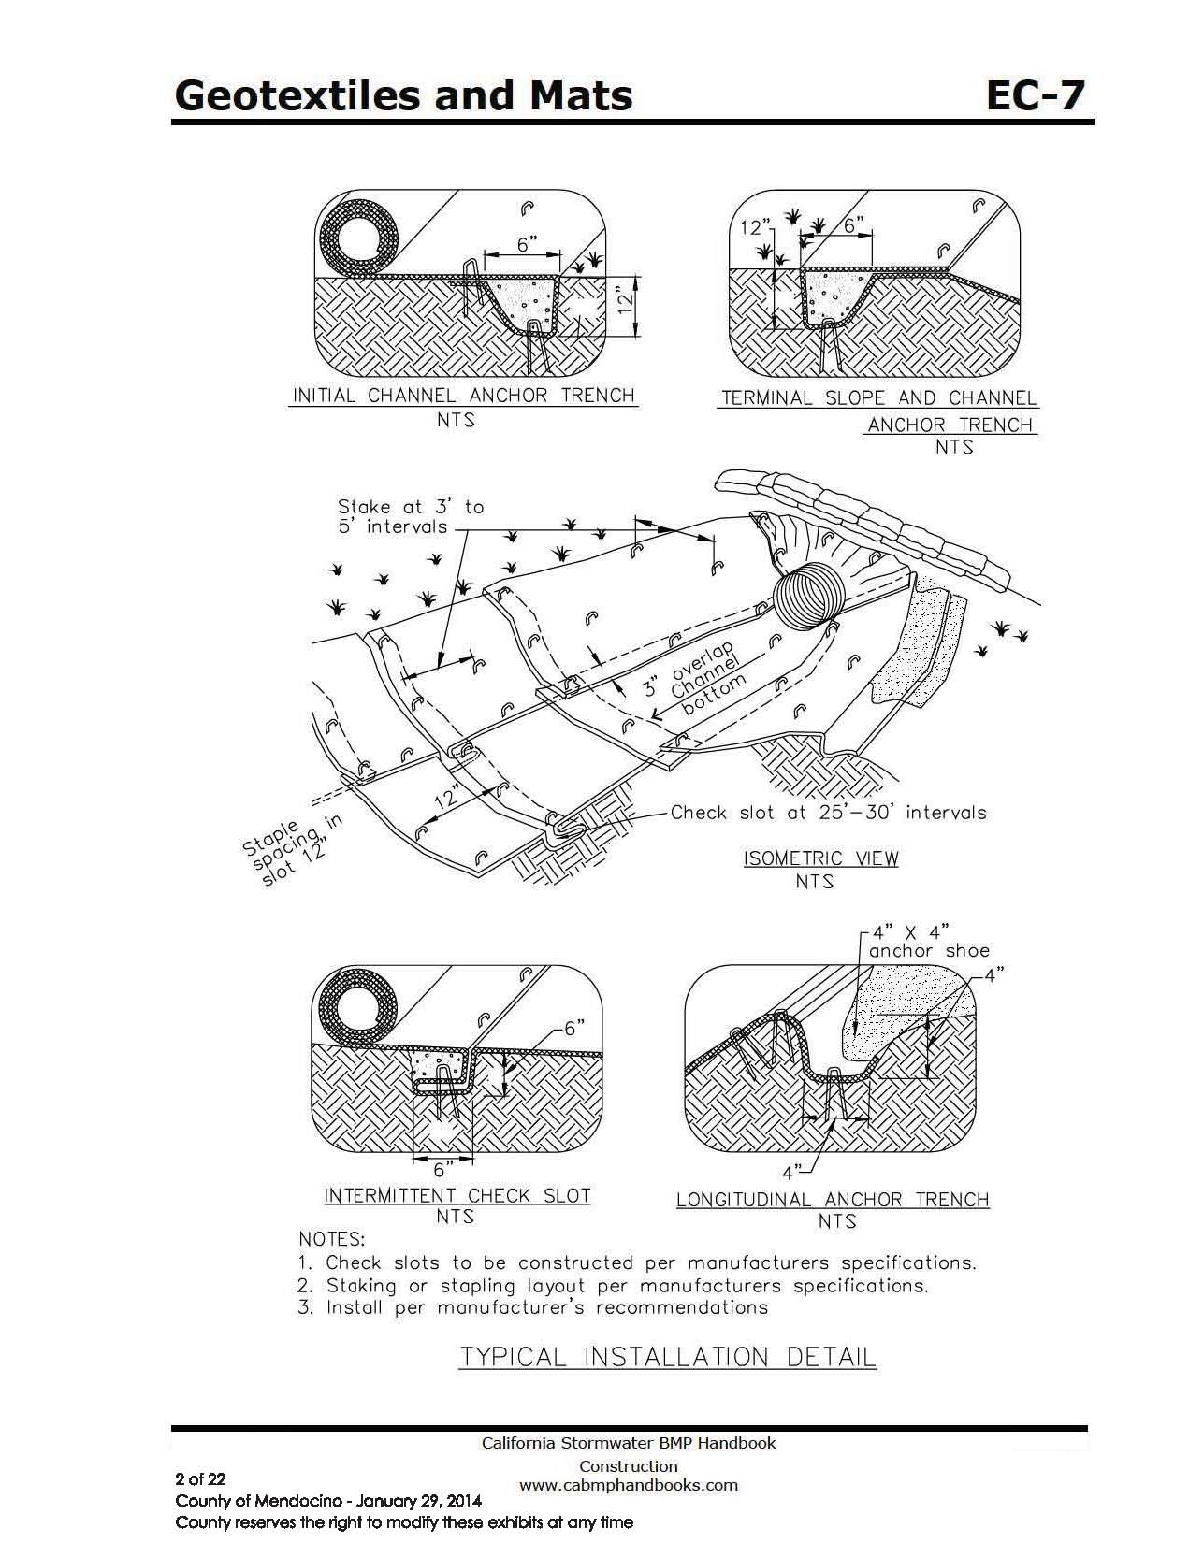
City reserves the right to modify these exhibits at any time

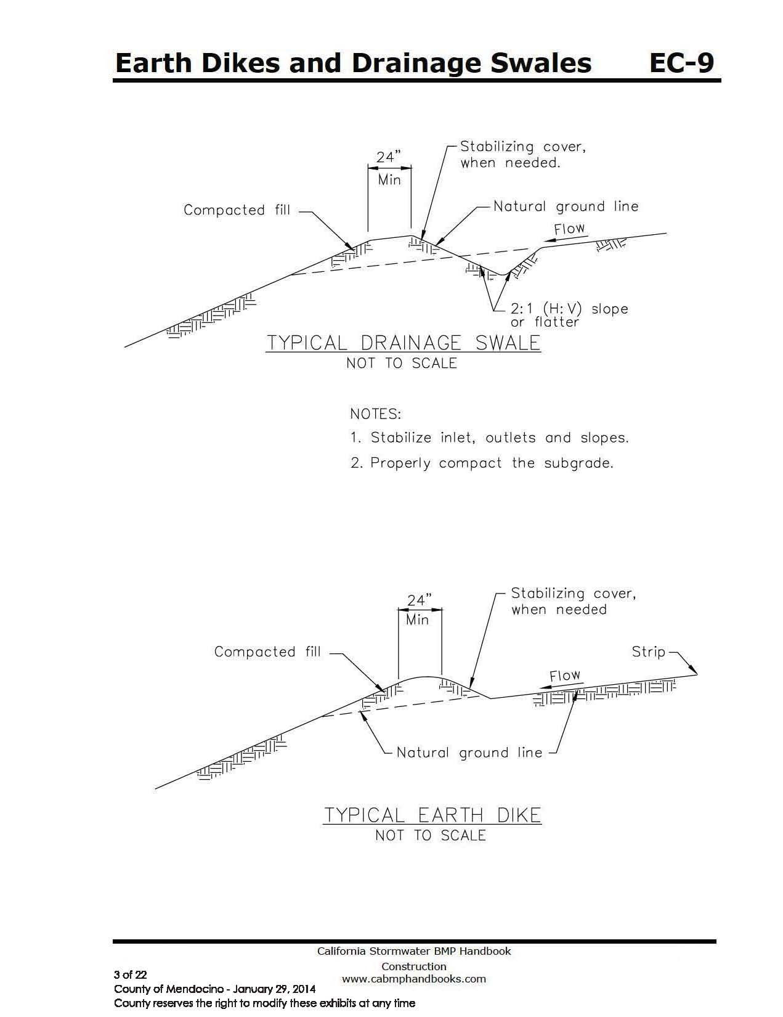

City reserves the right to modify these exhibits at any time

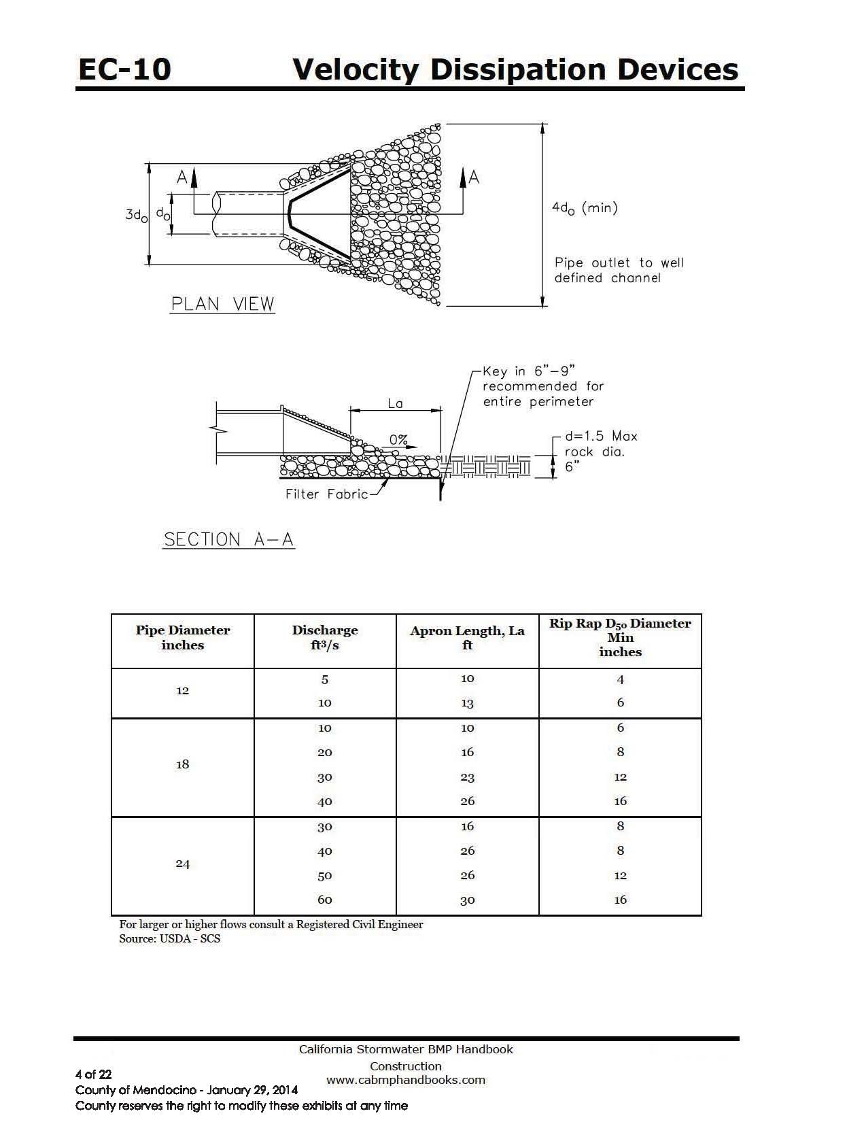

City reserves the right to modify these exhibits at any time
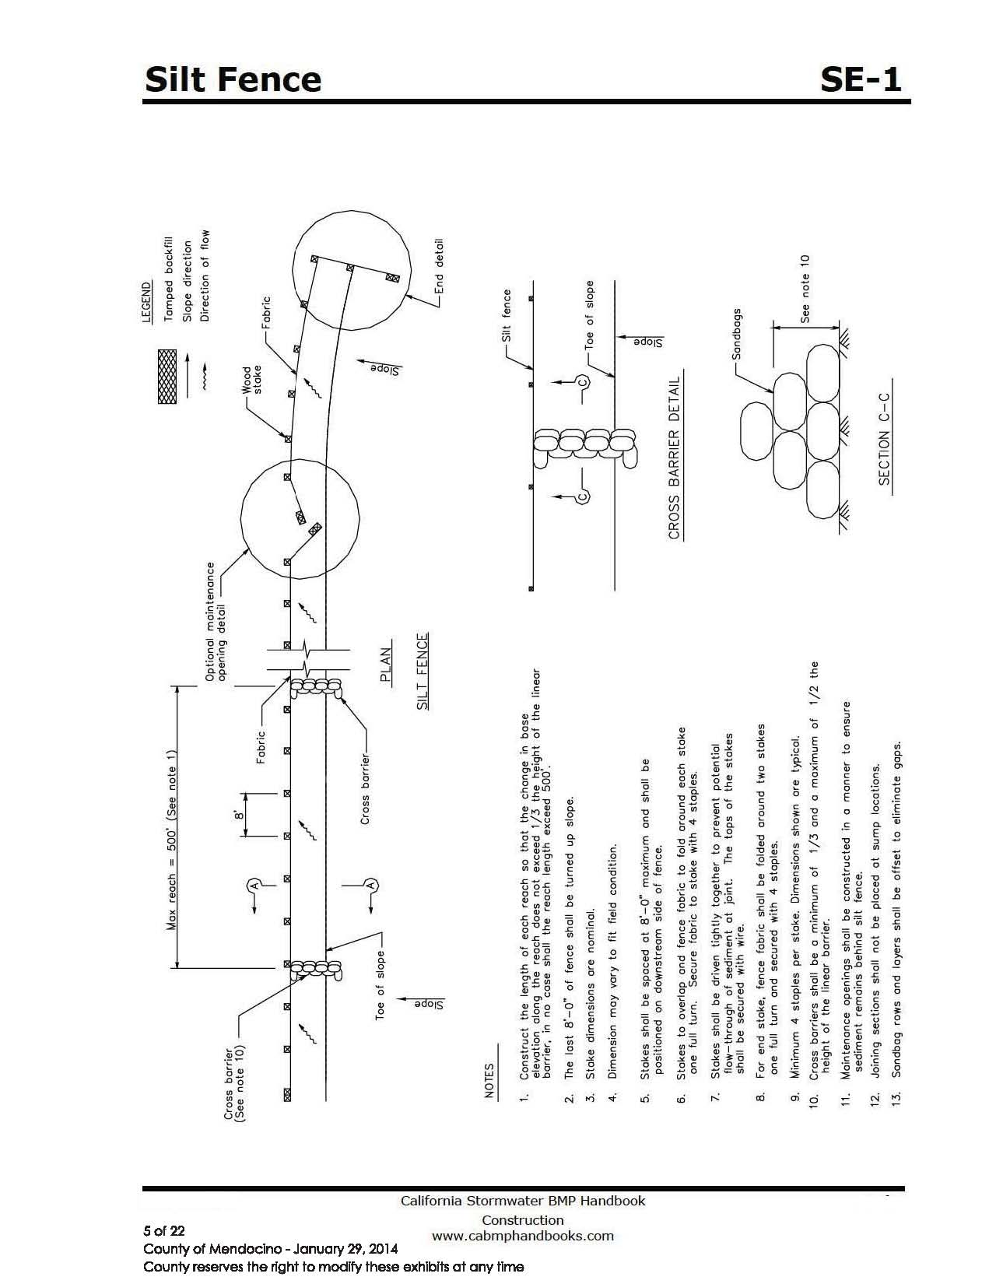

City reserves the right to modify these exhibits at any time

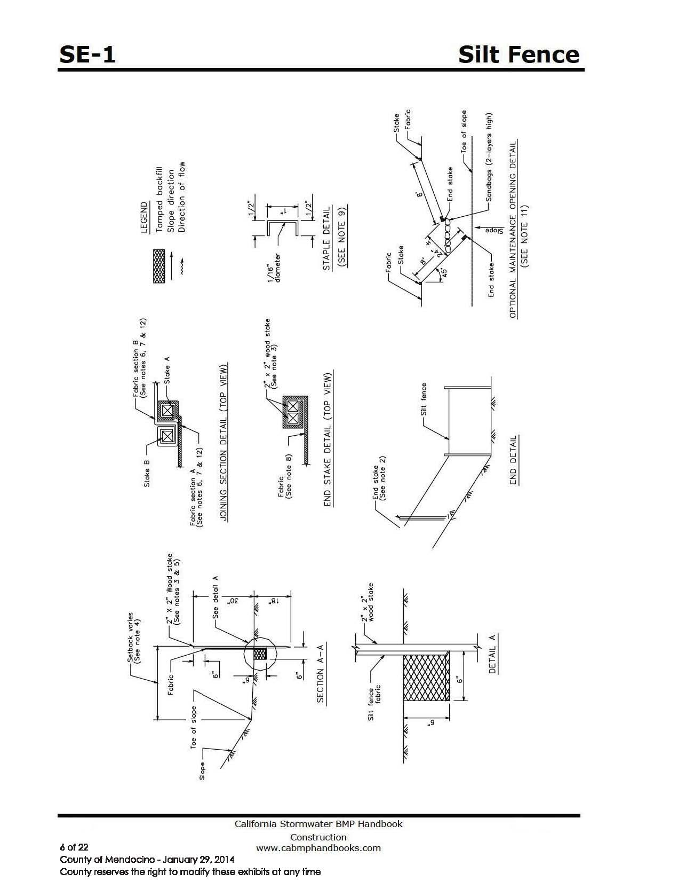

City reserves the right to modify these exhibits at any time

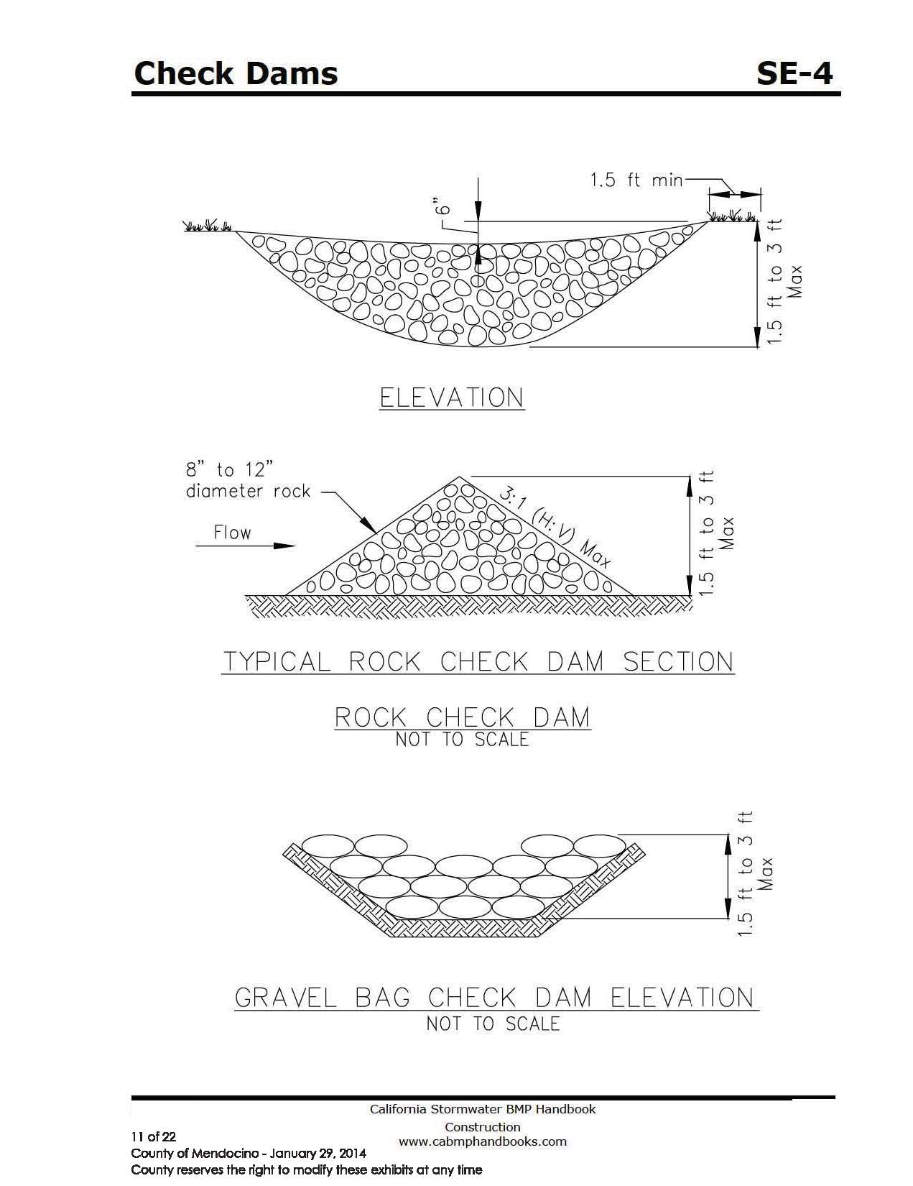

City reserves the right to modify these exhibits at any time

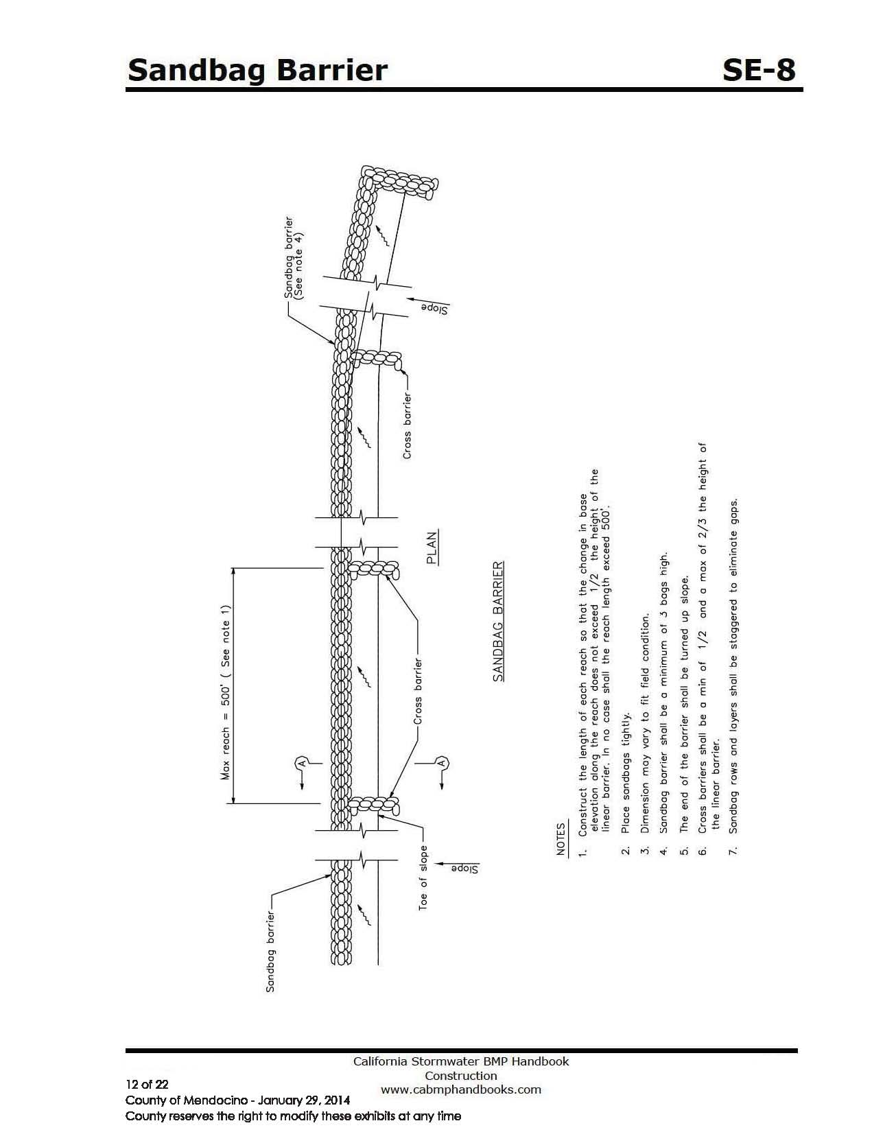

City reserves the right to modify these exhibits at any time
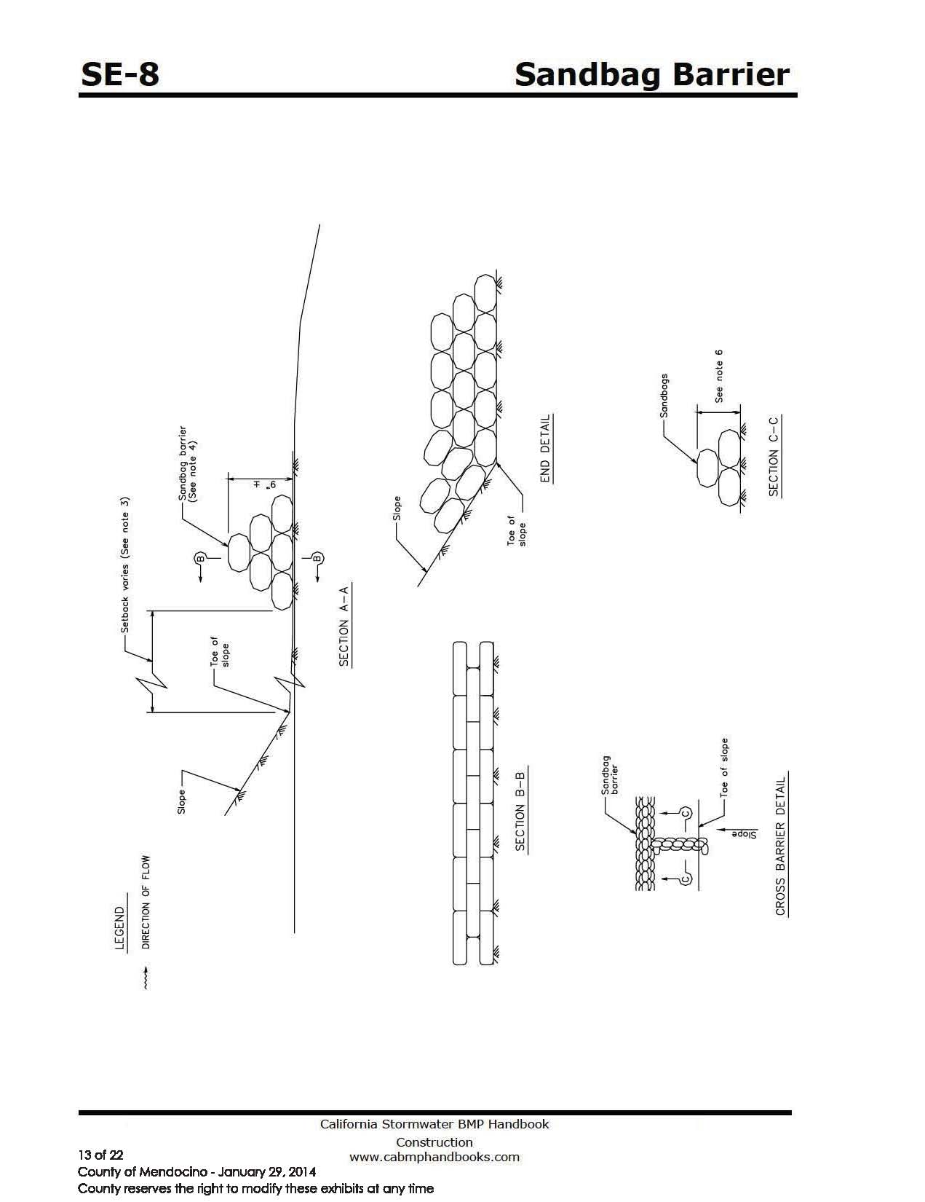

City reserves the right to modify these exhibits at any time

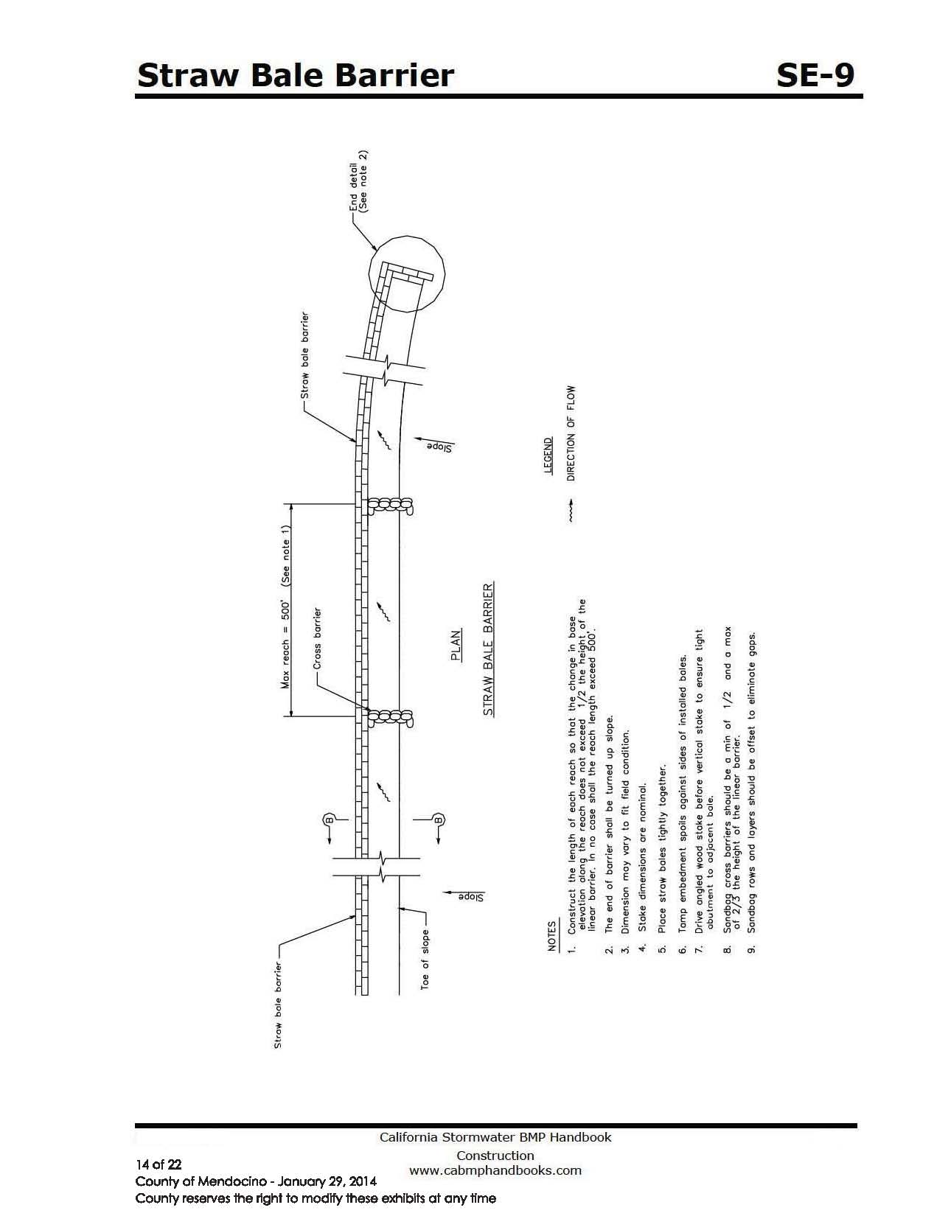

City reserves the right to modify these exhibits at any time
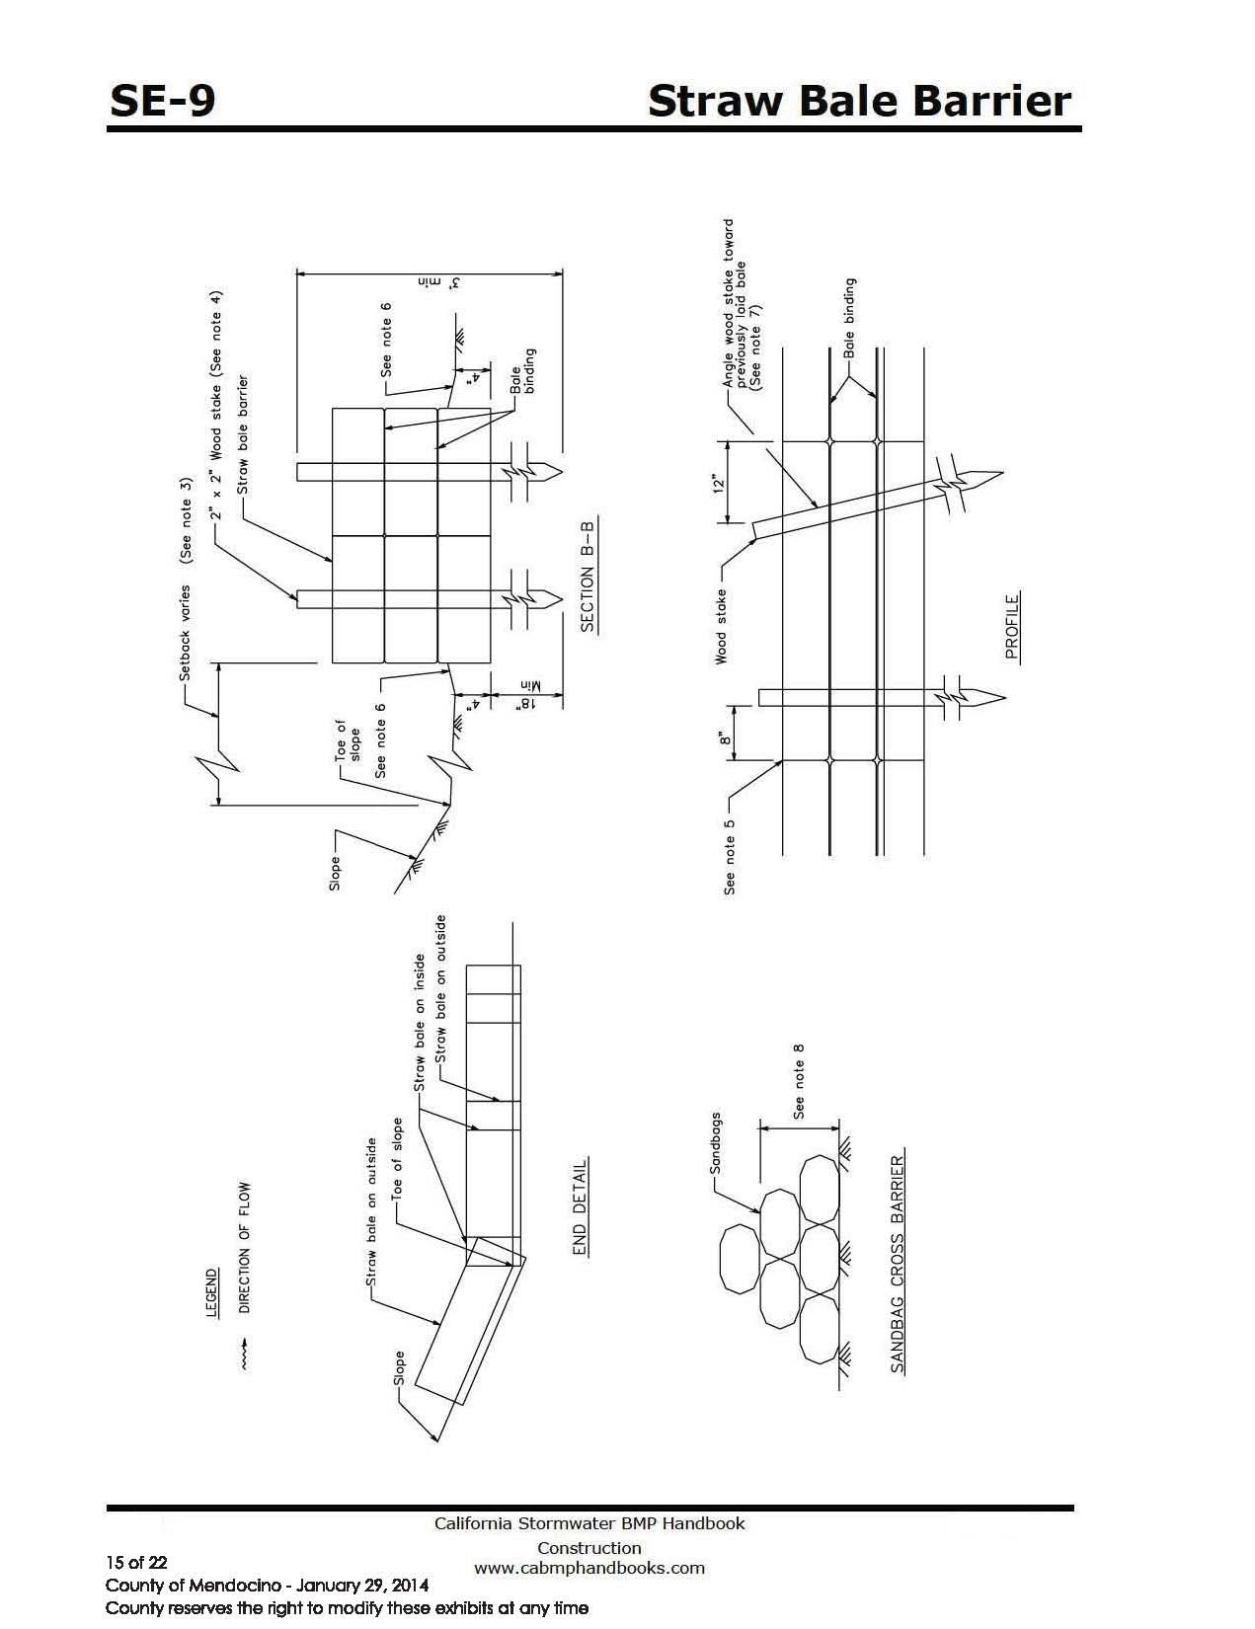

City reserves the right to modify these exhibits at any time

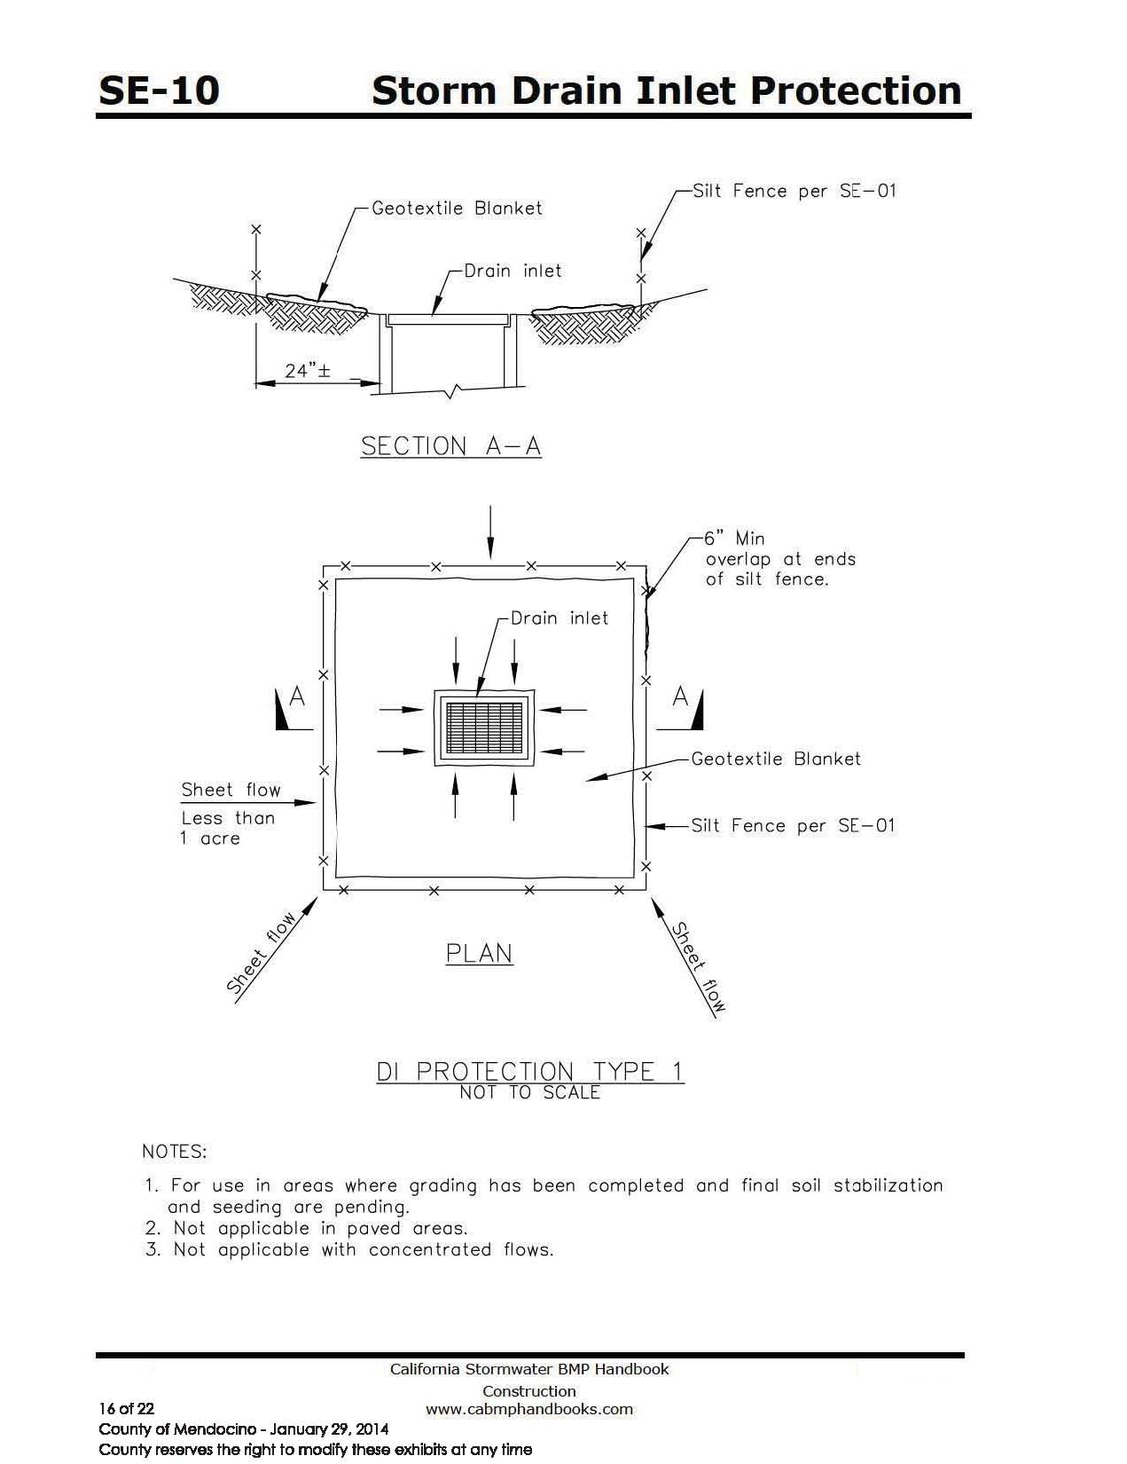

City reserves the right to modify these exhibits at any time

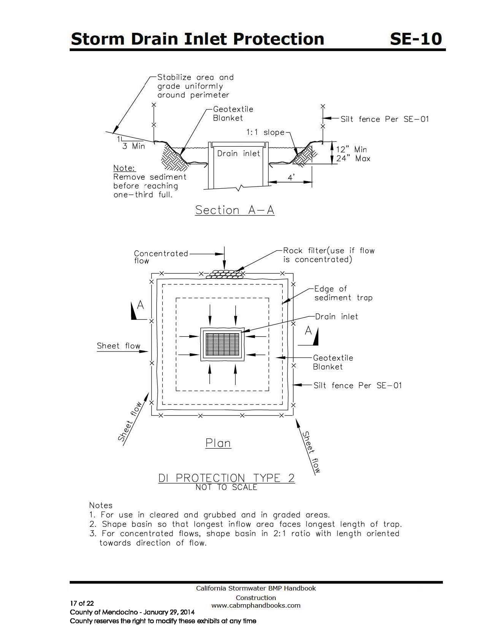

The City reserves the right to modify these exhibits at any time

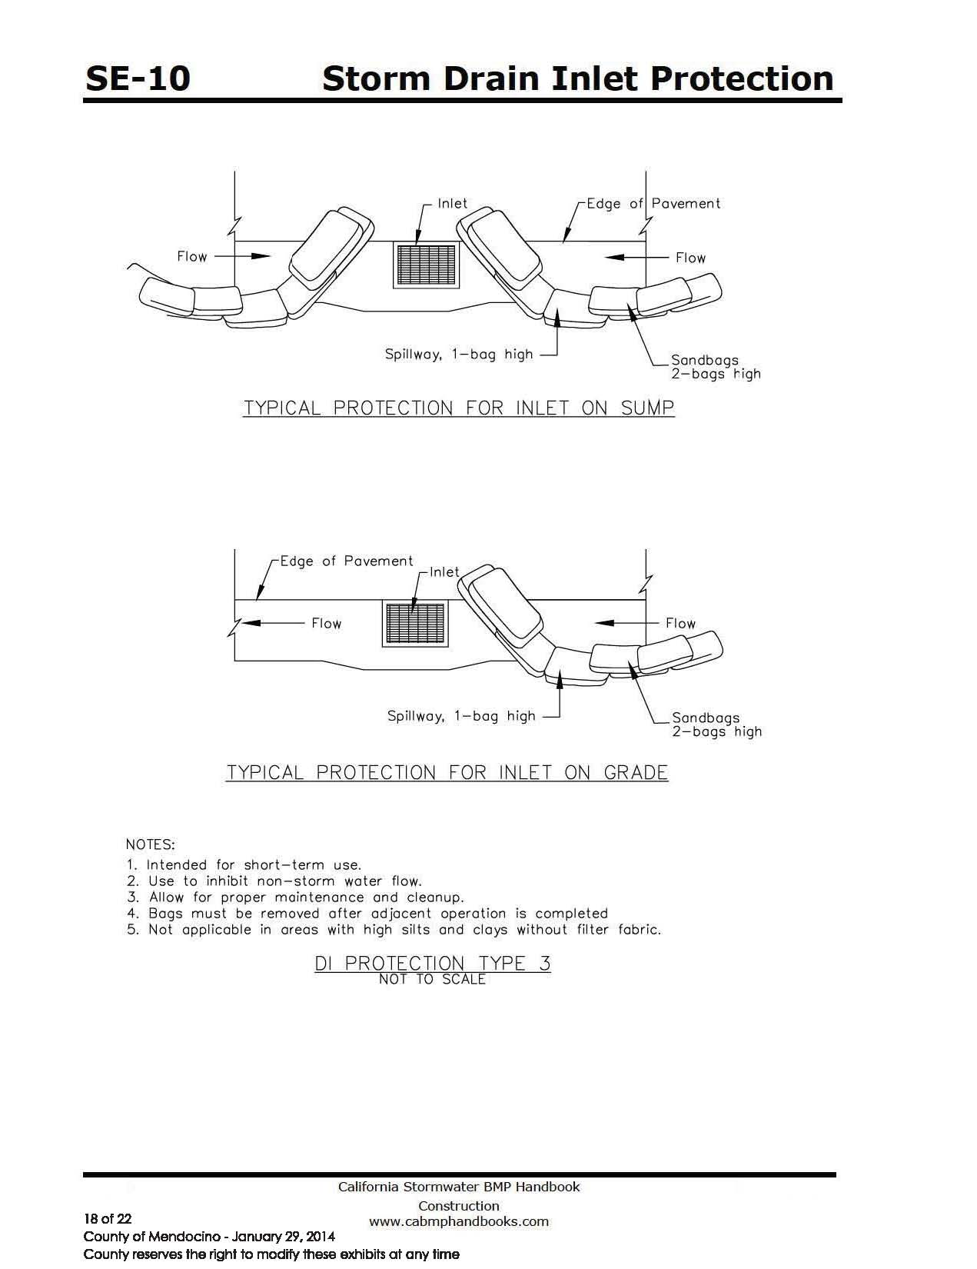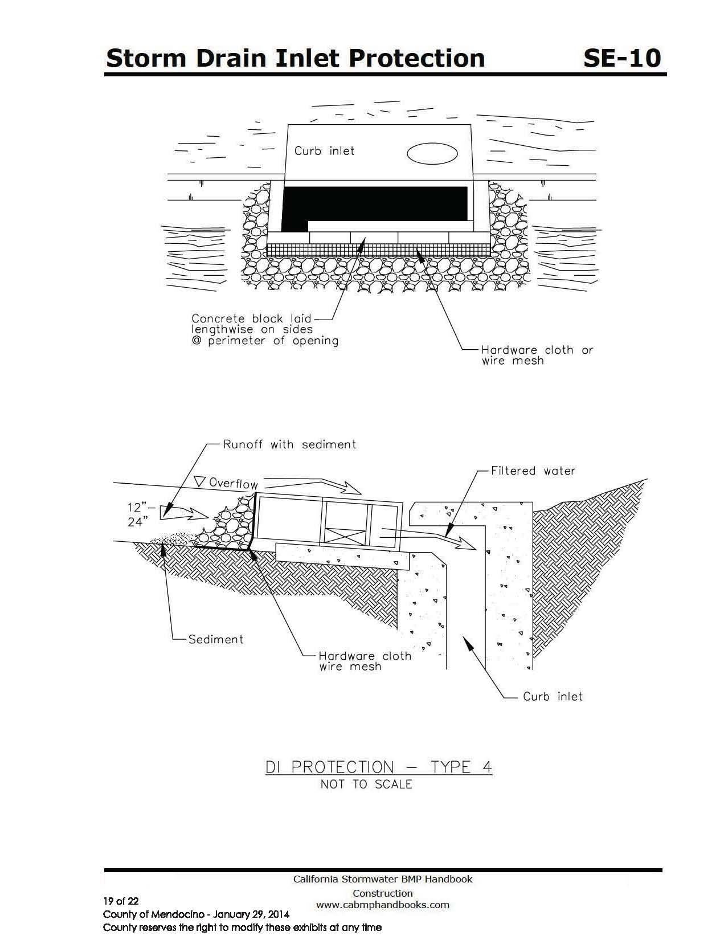

City reserves the right to modify these exhibits at any time

City reserves the right to modify these exhibits at any time

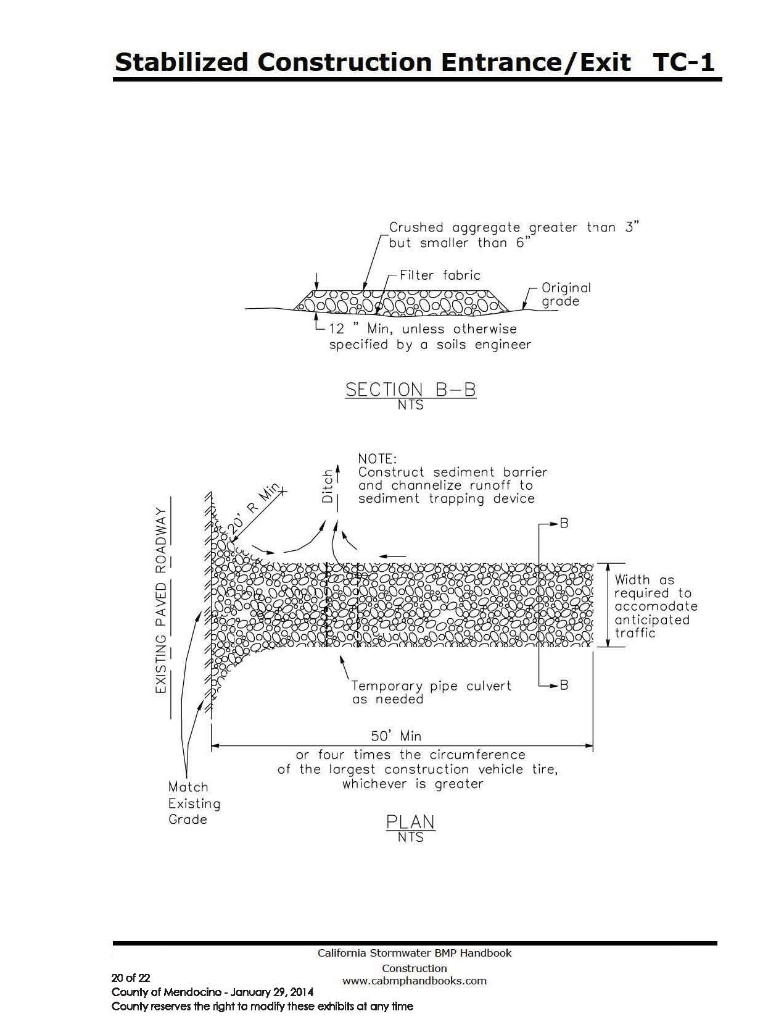

City reserves the right to modify these exhibits at any time

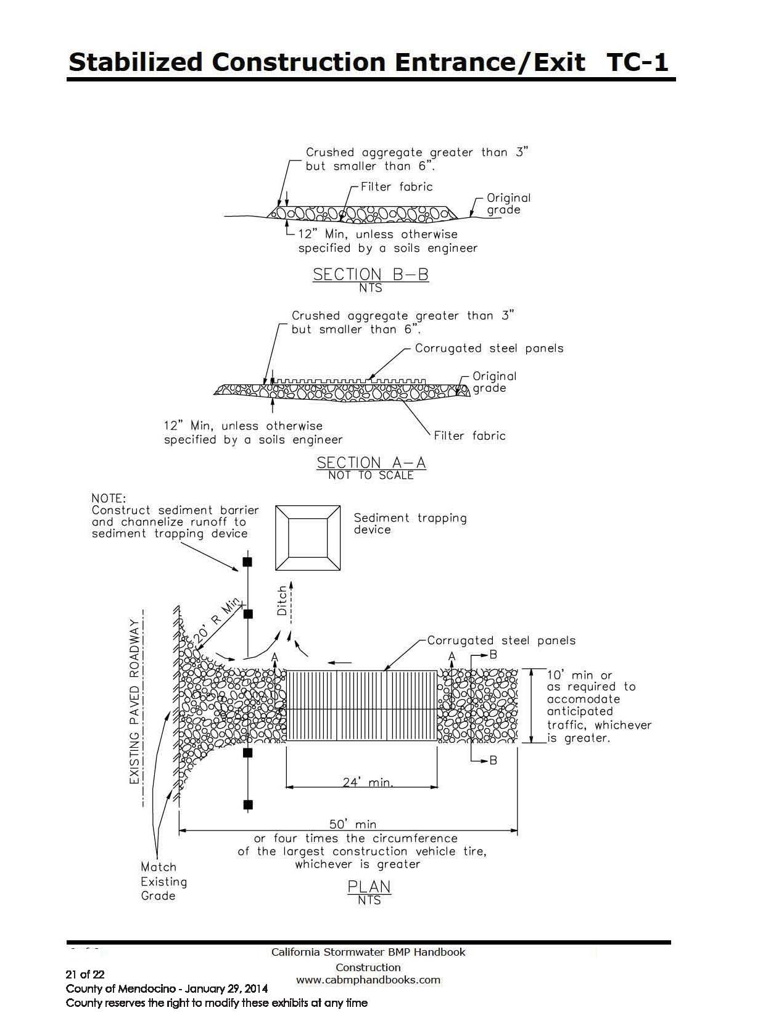

City reserves the right to modify these exhibits at any time

